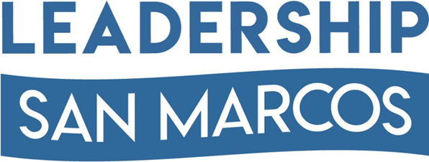

Leadership San Marcos provides community awareness, personal and professional growth, and civic involvement for tomorrow’s leaders.

2018 SCHOLARSHIP
Application Form

Name Tel#

Address City/State/Zip

Name of High School City /State

Parent/Guardian/Grandparent Name Tel#

(Applicant’s Signature)

Please read the eligibility requirements below. Complete this form and the attached questionnaire and forward both, along with official transcript, resume and referral letters to:

Leadership San Marcos
P.O. Box 1144
San Marcos, TX 78667

The amount and number of the scholarships will be determined by the Leadership San Marcos Board.

All applicants must be available for an interview.

The Leadership San Marcos Scholarship Committee will make final recommendation to the
Board for approval.

The scholarship will be sent directly to the state-accredited college, university, or technical/trade school chosen by the recipient.

IMPORTANT: THE DEADLINE FOR SUBMITTING THIS APPLICATION IS: MARCH 15, 2018
Mailed application must be post-marked on or before March 15, 2018

ELIGIBILITY REQUIREMENTS
• The student’s parent/s, primary guardian, or grandparent must be a LSM Alumni Association member for the current and at least, the past 2 years of when application is submitted.
• The student must be a graduating senior during the school year that the scholarship is awarded.
• The student must have a 2.75 GPA or above.
• The student must agree to enroll as a full-time student at a state-accredited college, university, or technical/trade school.
• The student must agree to attend classes as prescribed by the school’s curriculum for the semester for
which tuition is paid.

In all cases the LSM Board of Directors will have the final decision on eligibility of each applicant, and, if for any reason an applicant is found to be ineligible by the scholarship committee, the scholarship shall not be awarded.

Email: Scholarship@LeadershipSanMarcos.org

www.LeadershipSanMarcos.org
2018 SCHOLARSHIP

Email: Scholarship@LeadershipSanMarcos.org

www.LeadershipSanMarcos.org

Questionnaire

Please submit the following documents with the completed application.
• Resume
• Official high school transcript
• Two (2) referral letters (school or other affiliation)

In addition, please answer the questions listed below completely. Answer briefly but make the information accurate and thorough. The Scholarship Selection Committee will use this information in judging the applications.

1. Why do you feel it is important to continue your education?

2. What would you say are your academic strengths?

3. What academic challenges have you had to face?

4. What career do you plan to seek after college?

Why?

5. How are you presently planning to finance your higher education?

6. List organizations, clubs, church, youth groups, or other activities of which you are a member, and awards you have received.

7. What was your class ranking?

8. List any community involvement or volunteer activities.

9. Who has been most influential in your decision to further your education and why?

Use the space below for additional information you might care to present concerning yourself, your scholastic or extracurricular achievements, or your future plans.

(Applicant’s Signature)

